Pack 55 Cub Scouts Official Rules for 2013!
Clinton, CT
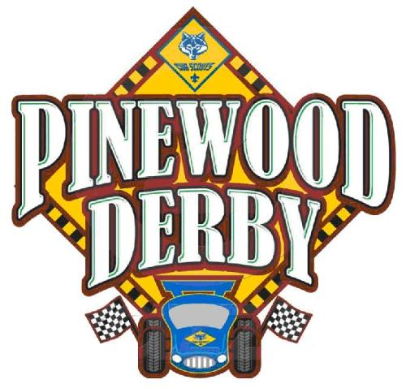
All cars must pass the following inspection to qualify for the race:
- Width shall not exceed 2-3/4 inches
- Length shall not exceed 7 inches
- Weight shall not exceed 5 ounces (141.75 grams)
- Axles, wheels, and body shall be from the materials provided with the kit
- Wheel bearings, washers, and bushings are prohibited
- Wheels may be sanded but cannot be altered in basic shape. All wheels are to be the "official BSA" marked on the inside of each wheel. No hubcaps are allowed. Wheels may not be rounded or "V-notched", grooves cut into the tread, or width narrowed. The raised lettering on the outside of the wheel must not be removed.
- The distance from the front and rear wheels may be altered, however the wheels cannot extend the overall dimensions of 7 inches.
- Axles supplied from the kit are to be used. They may be filed, sanded, polished, but no plating allowed. ONLY OFFICIAL BSA AXLES ARE ALLOWED. Inspectors can tell the difference!
- No lubricating oil may be used. Dry lubricant only! Axles may be lubricated with powdered graphite or silicon.
- The car shall not ride on any springs or struts.
- The car must be free-wheeling, with no starting devices.
- The front of the car cannot extend past the starting post, for example forked front.
- Body details such as windshields, steering wheels, drivers, etc may be added but must be securely fastened to the car.
- The track contains a center strip 0.75" wide and 0.225" high. Please ensure there is sufficient clearance from the bottom of the car to the center strip. It is not recommended to add anything to the bottom of the car which may interfere with the center strip. When adding weight, drilling holes flush from bottom or ends is recommended. The bottom weight plates if surface mounted may interfere unless sunken into wood.
- If problems occur, contact William Loth, Asst Cubmaster, as we have spare kits.

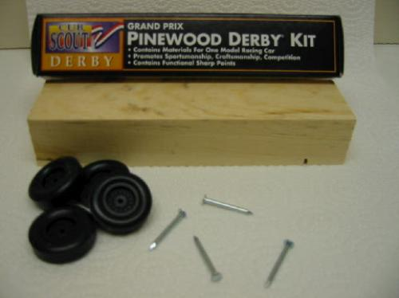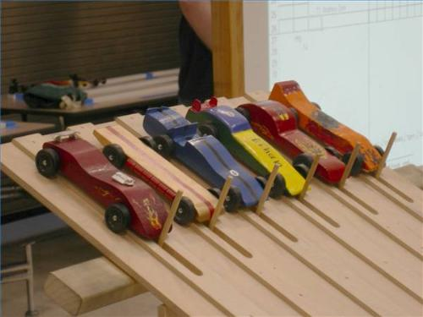
Inspection & Weigh In: When you first arrive, cars may be tuned up and lubricated and given ONE test run only. Then you will take to the inspection station for inspection and weigh in. For weigh in, we will use a digital scale. If you do not pass initial inspection, there will be a table set up to make adjustments. When you have passed the inspection, cars will be moved by the scout to the official race table. After this point, no cars may be touched until the time of the race, and only by the scout. No additional lubrication may be done after the car passes the inspection. During the race, if special circumstances exist, like a car getting dropped or flying off the track, may emergency repairs be made. This process of weighing all the cars and inspection usually take about 60-90 minutes.
Awards: Trophies will be awarded for the following:
SCOUTS:
1. Fastest Car Overall, 1st place
2. Fastest Car Overall, 2nd place
3. Fastest Car Overall, 3rd place
4. One trophy for Best in Show
5. One trophy for Most Creative
6. One trophy for “Best Theme” or “Most Innovative”
POWDER PUFF (GIRLS race): Note girls may race cars in the Powder Puff competition. They will have to purchase their kit for $5.00. Same rules apply to them as the scouts. One trophy will be awarded for fastest girl
ADULT RACE: Adults will start with basic kit, but do not follow the basic rules. Cars will have to weigh a maximum of 10 oz, and may have starting assistance within reason (no flames), etc. The fastest car will get a trophy! Purchase price for the kit is $25.00. The additional money helps to go towards the trophy.

